**1) Program 1:**

print("Question 1...\n")

list = [8,4,6,3,5]

print("The list..")

for i in range(len(list)):

print(list[i])

list.insert(3, 2)

print("\nA) After Inserting Integer 2 at index 3")

for i in range(len(list)):

print(list[i])

list.remove(list[0])

print("\nB) After Removing the first occurance")

for i in range(len(list)):

print(list[i])

list.append(7)

print("\nC) After appending 7")

for i in range(len(list)):

print(list[i])

list.sort()

print("\nD) After sorting")

for i in range(len(list)):

print(list[i])

list.pop()

print("\nE) After pop")

for i in range(len(list)):

print(list[i])

list.reverse()

print("\nF) After reversing")

for i in range(len(list)):

print(list[i])

**OUTPUT OF PROGRAM 1:**

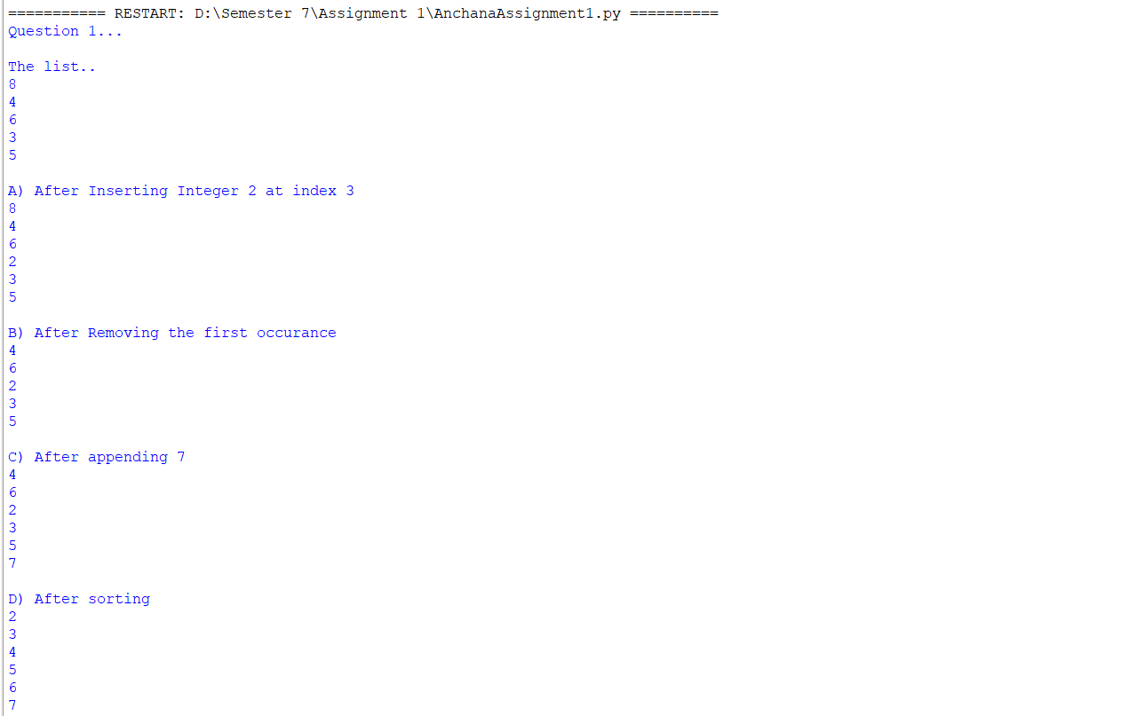

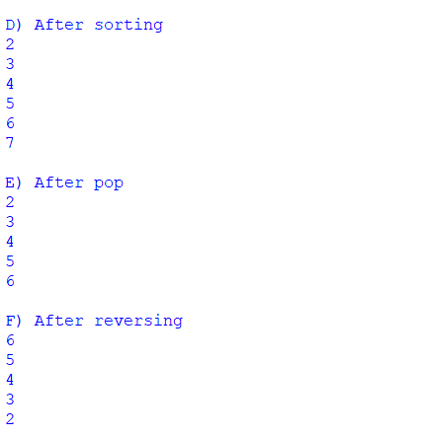

**2) Program 2:**

print("\nQuestion 2...\n")

n1=10

n2=5

print("Integer 1 : ",n1,"& Integer 2 :",n2)

print("Addition : ",n1+n2)

print("Subtraction : ",n1-n2)

print("Multiplication : ",n1*n2)

print("Division : ",n1/n2)

print("Modulus : ",n1%n2)

print("Exponentiation : ",n1**n2)

print("Floor division :",n1//n2)

**OUTPUT OF PROGRAM 2:**

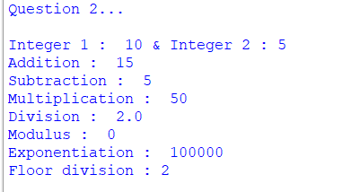

**3) Program 3:**

print("\nQuestion 3...\n")

str = "Anchana"

print("The string is : ",str)

str1=" Prabakaran"

print("A) Concatenation of the String :",str+str1)

str2=""

for i in str:

str2 = i + str2

print("B) The reverse of the String *Anchana*: ",str2)

x=slice(3,5)

print("C) Slicing of the String *Anchana* : ",str[x])

**OUTPUT OF PROGRAM 3:**

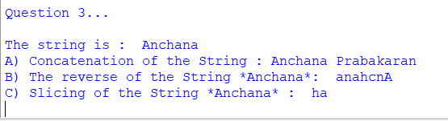

**4) Why is Python a popular programming language?**

Python is popular because it is easy to learn and has an active, support community. Python is also a flexible programming language because  it can be used to develop nearly any kind of application in any industry or field such as web-development solutions , data science and analytics etc. It is also fast, efficient and reliable allowing developers to create powerful applications with a minimum of effort. Completing coding projects is easy rather than time-consuming

**5)What are the other Frameworks that can be used with python?**

* Flask
* Django
* Pyramid
* Web2py
* Cherrypy
* Sanic

**6)Full form of WSGI:**

 Web Server Gateway Interface.